Name:________________________ Period:___________
Activity Sheet T3–1d Review 4
1. Order Greatest to Least:{3⅜, π 3.33, 3¾, 320%, } 2. Calculate the Mean Average Deviation: {9, 2, 5, 9, 7, 1, 5,11}
______________________________ _________________________________

3. Set A {3¼, 3, –π, 2.6, √5, 0,-8}: ⊂ B {n} =________________ 4. √160 = ____________
x 160⁰

5. –5.16 X 10^{–6} = _____________ 6. Find x:

7. –(– 4x + 5) – (–9x ) = 3(2x+8) x= _________ (For # 6.) x=________⁰

8. Bill has two jobs. The first job Bill work x hours. The second job he worked 4x + 3 hours. He worked a total of 66 hours minus 2x hours he took for lunch and travel. Find x. x = ________
9. x m 15m x = ________ 10. 4 m x x = ________

9 m slope =__________ (Bonus) 9 m

11. 4x = 18 x = ________ 12. 3x – 6 = 6x + 1 x = ________
12 3 2 9
5x +3 All ponts: (x,y)→(5x,5y)
13. 2x 2x x = ________ f(x) g(x)
x x Perimeter = 186m Area = 425m²
Perimeter = 19m
2x 2x
5x +3 14. Area f(x)= ________ 15. Perimeter g(x)= ________
16. Point A (8, –2) ; Find A' if A is Rotated 90⁰ (counter clockwise) A'= _________

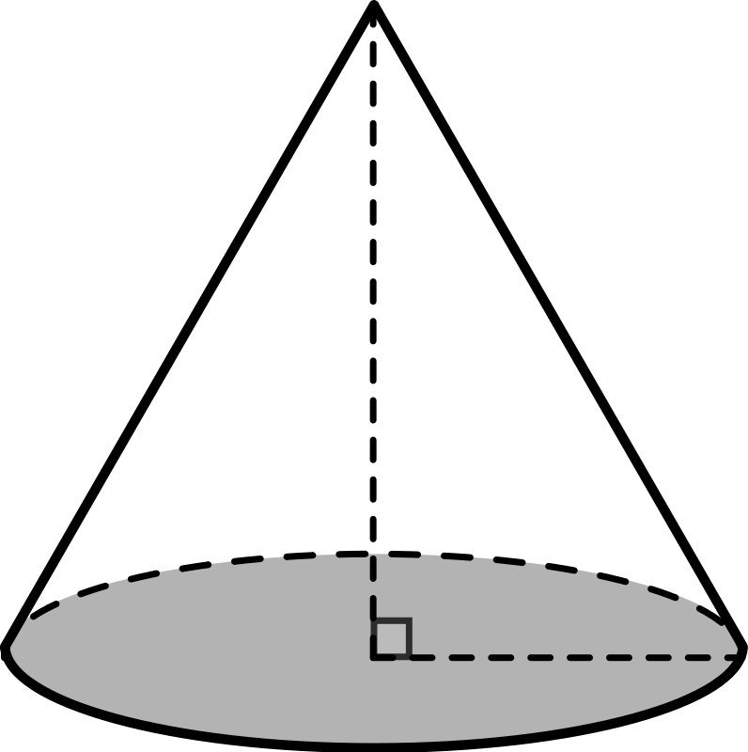
17. Volume: ____________ 18. Total amount & Simple interest:
10m $800 @ 9% per year for 6 years

5m (18.)Total:__________ Interest _________
(Bonus)

19. Translation {x+7},{y–2} of point (– 5, – 5.5). Location_________ 20. Quadrant: ______

Determine the proportionally, slope and equation of table (a.).
(a.)
Price(x) Shipping Costs(y)

  - 1.00
  - 1.50
  - 2.00
  - 2.50
  - 3.00
Is table (a) Proportional? 21. ______________

What is the Slope for table (a)? 22. ______________

What is the equation for table (a)? 23. _______________

